**Lab 3: Introduction to Amazon EC2**

Paul Polsinelli

Information Technology, Arizona State University

IFT 472: Managing the Cloud

Professor Neff

Sep 6th, 2020

**Lab 3: Introduction to Amazon EC2**

**Figure 1**

*A screenshot of review of instance launch*

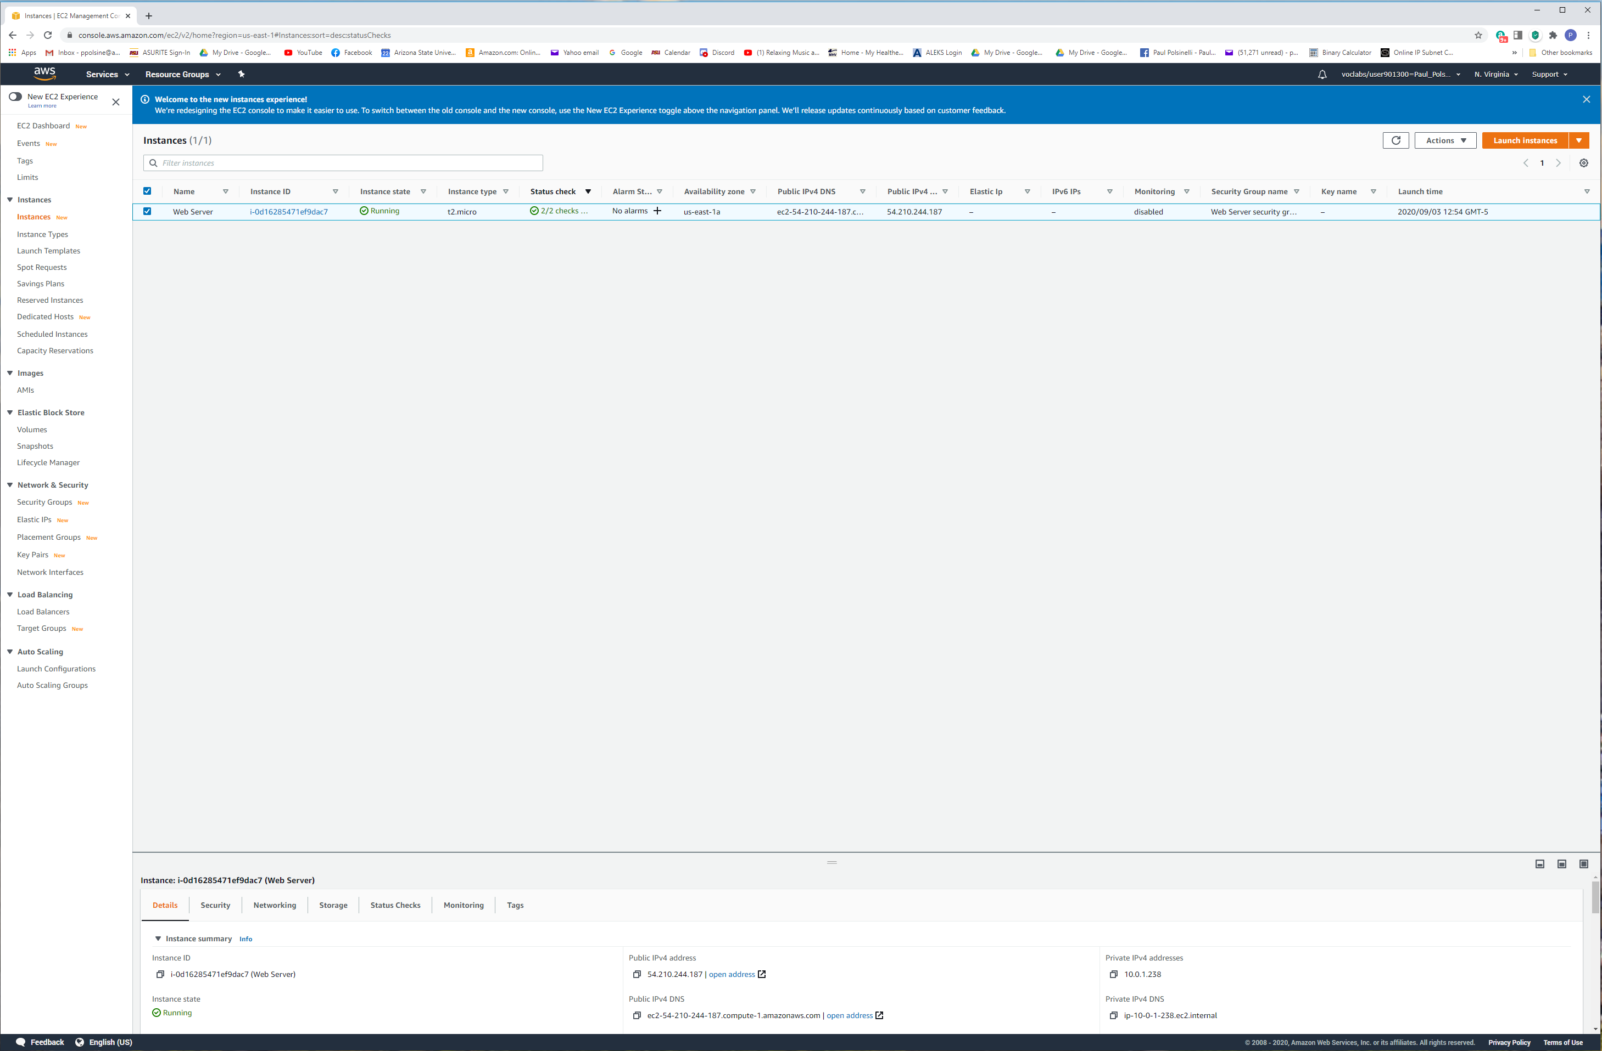

**Lab 3: Introduction to Amazon EC2**

**Figure 2**

*A screenshot of the instance screenshot*

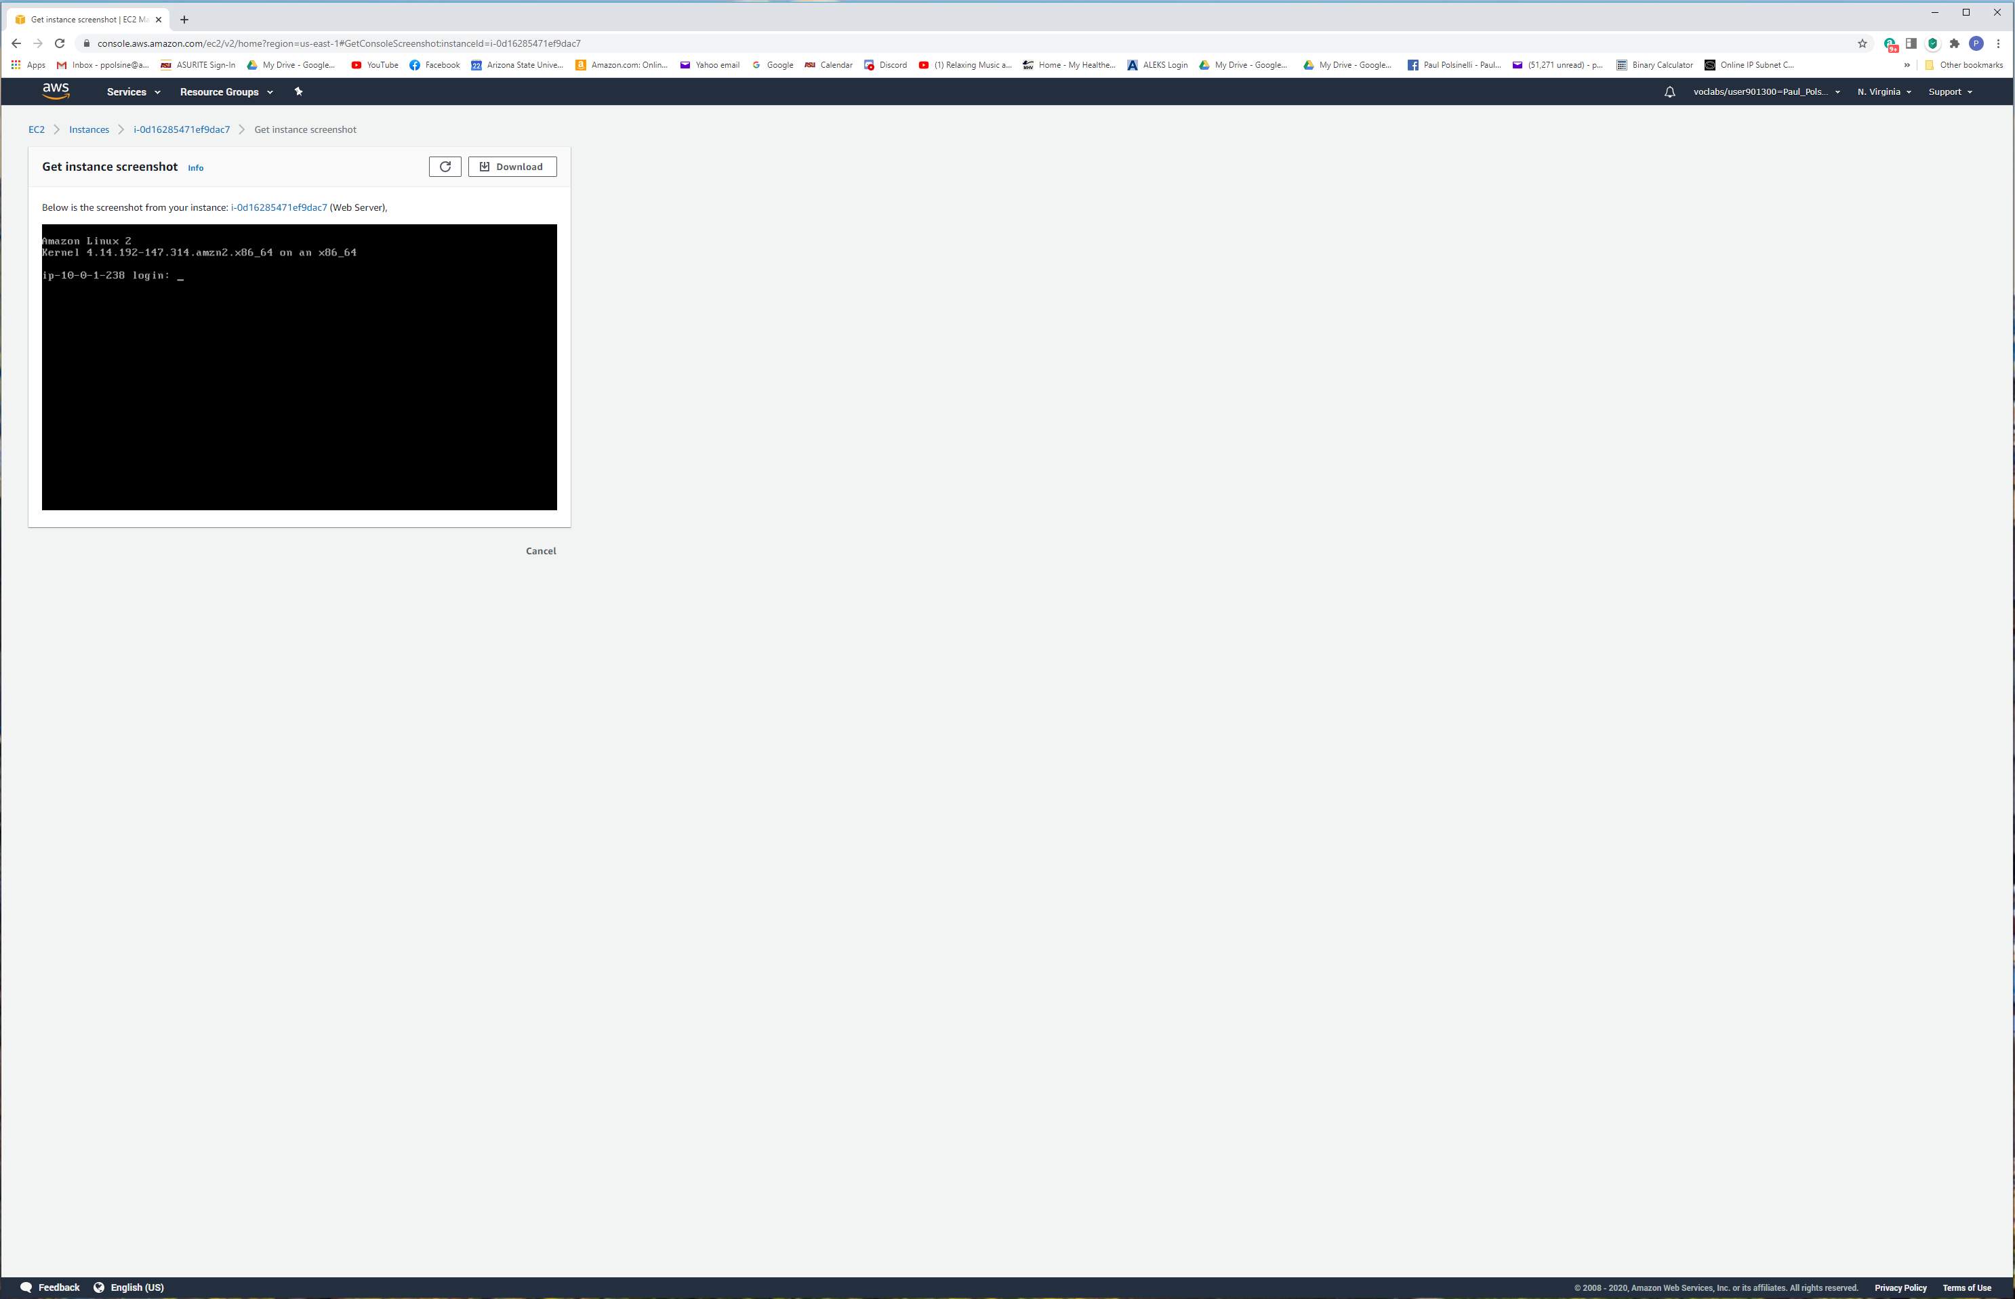

**Lab 3: Introduction to Amazon EC2**

**Figure 3**

*A screenshot of the security settings*

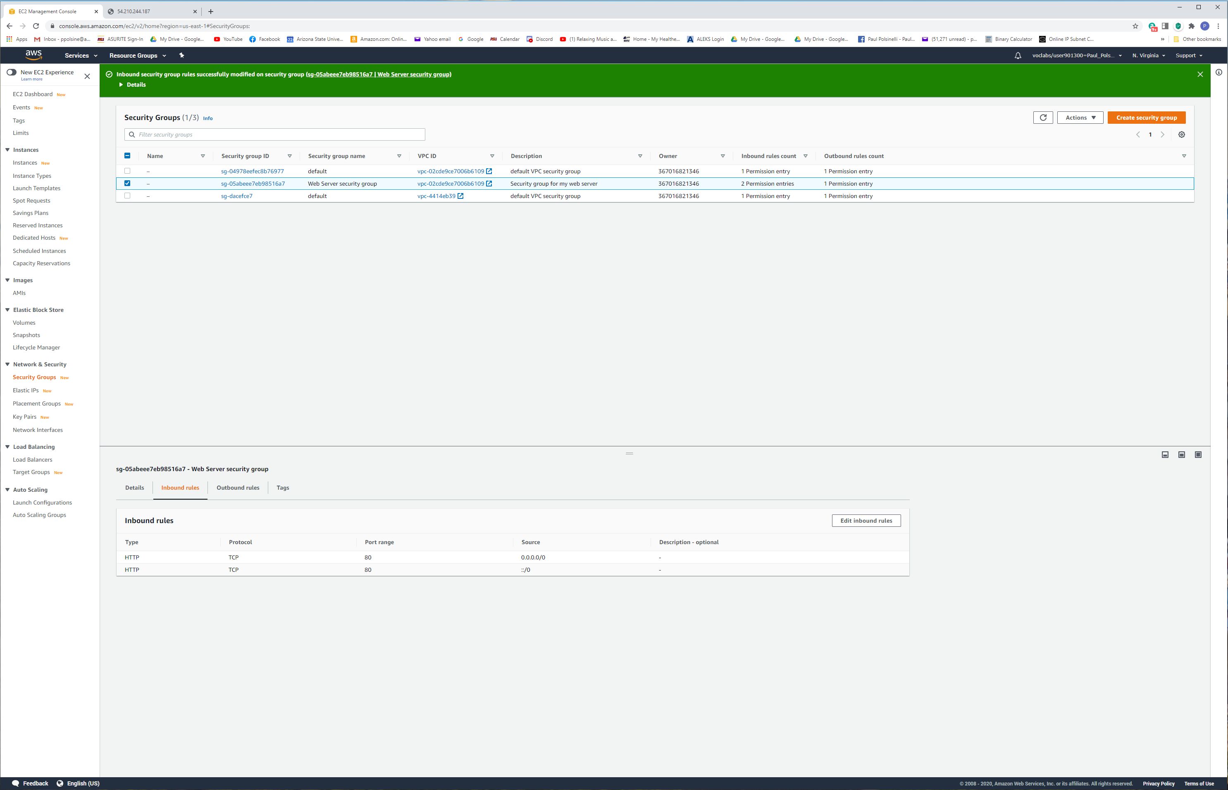

**Lab 3: Introduction to Amazon EC2**

**Figure 4**

*A screenshot of the instance details*

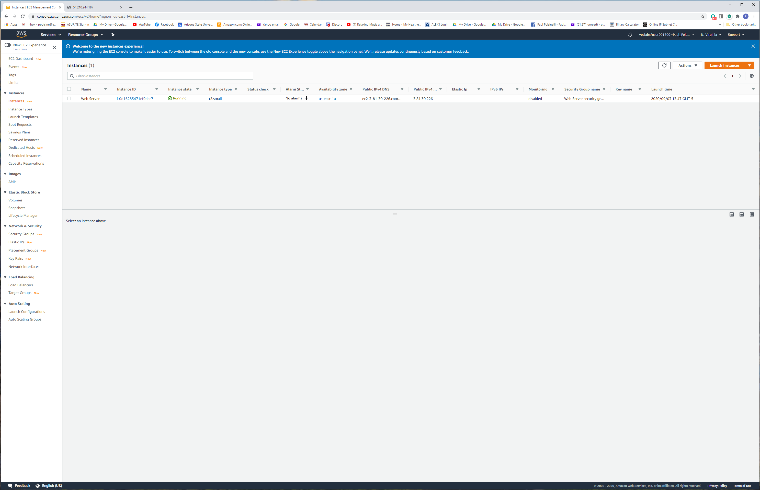

**Lab 3: Introduction to Amazon EC2**

**Figure 5**

*A screenshot of the terminate error*

